Export Space from Confluence Process

Contents

Export Space and Select Pages 2

Download the zip and extract to a local folder 3

Clone repos 4

Execute PowerShell Script 4

Important Notes 5

Known Issues 6

# Export Space and Select Pages

# Download the zip and extract to a local folder

# Clone repos

<https://github.com/chrh-sitecore/developer-portal>

<https://github.com/chrh-sitecore/confluence-to-markdown>

# Execute PowerShell Script

In confluence-to-markdown repo:

.\ConvertTo-Markdown.ps1 -InputPath "e:\export" -OutputPath "output" -DeveloperPortalFolder "E:\projects\developer-portal"

# Important Notes

The table on each confluence page needs all fields populated. The **Project Step** and **Chapter** define the page’s level in the developer portal hierarchy.

In the below case, the page will be copied to /implementation/custom-logic.

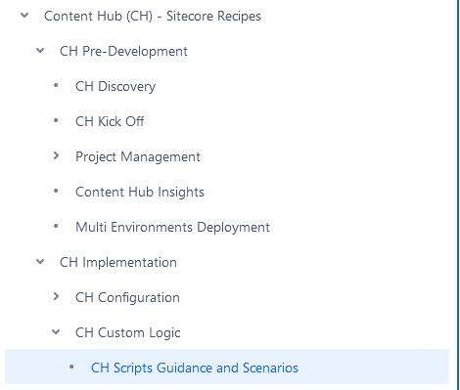

# Known Issues

Pages should have ‘CH-‘ stripped from all internal links and all filenames. This should be automated, although could be done manually.